Research Update 1

1. State Before This Work
Phase 2 delivered a working XGBoost classifier trained on 63 signal features extracted from 60 clean milling datasets. The model achieved an out-of-fold AUC of 0.968 and F1 of 0.901 under leave-dataset-out cross-validation. SHAP analysis confirmed that force-based spectral features dominated predictions, with Forcex_spectral_entropy scoring the highest mean SHAP value at 0.501.
That result solved the detection problem: given extracted features, the model reliably identifies chatter. It left the physics question unanswered: what governing equation produces chatter, and which terms in that equation separate stable cutting from instability? Phase 4 addresses this. SINDy-DDE operates on raw simulation signals rather than handcrafted features, fitting a sparse differential equation directly from time-series data. SINDy is used explicitly as an analytical baseline: it selects terms from a human-curated library (data manipulation), while the KAN-PINN in Phase 5 will learn dynamics without a predefined candidate set. The SINDy results set the floor for what classical sparse regression can recover.

2. Methodology
SINDy-DDE treats equation discovery as a sparse regression problem. For each simulation file, it constructs a matrix of candidate terms from the state variables (tool displacement x, velocity dxdt, and the regenerative chip thickness term chip_x = x(t) minus x(t minus tau), where tau is the tooth-pass period). Sparse regression then selects which terms, combined, best predict the acceleration signal. A term is included if it receives a nonzero coefficient. The nine-term library used here covers the linear dynamics (x, dxdt), nonlinear stiffness and damping (x squared, dxdt squared, x times dxdt), and four chip-coupled regenerative terms (chip_x, chip_x squared, x times chip_x, dxdt times chip_x).
The full run covered all 120 datasets: 32,168 files total (16,548 stable, 15,620 unstable), across noise tiers of 0% clean (datasets 1 to 60), 1% noise (61 to 90), and 5% noise (91 to 120). Four analyses were run: aggregate term inclusion by stability label, per-dataset replication of the chip_x discrimination pattern, a b/blim gradient test to see whether chatter physics emerges sharply or gradually at the stability boundary, and a noise-tier comparison restricted to matched datasets 1 to 30 and their noisy mirrors.

3. Results and Discussion

Dataset 1: chip_x as the chatter signature
The single-dataset preview on Dataset 1 (102 files) gave the clearest signal. chip_x inclusion jumped from 10% in stable cuts to 76% in unstable cuts, a 7.6x ratio. The squared chip term (chip_x squared) went from 0% to 48%. Cross terms x times chip_x and dxdt times chip_x both ran below 6% in stable cuts and above 47% in unstable. Every chip-coupled term activated under chatter and stayed suppressed under stable cutting. The linear terms x and dxdt appeared near-universally in both labels, as expected for the linear oscillator backbone.
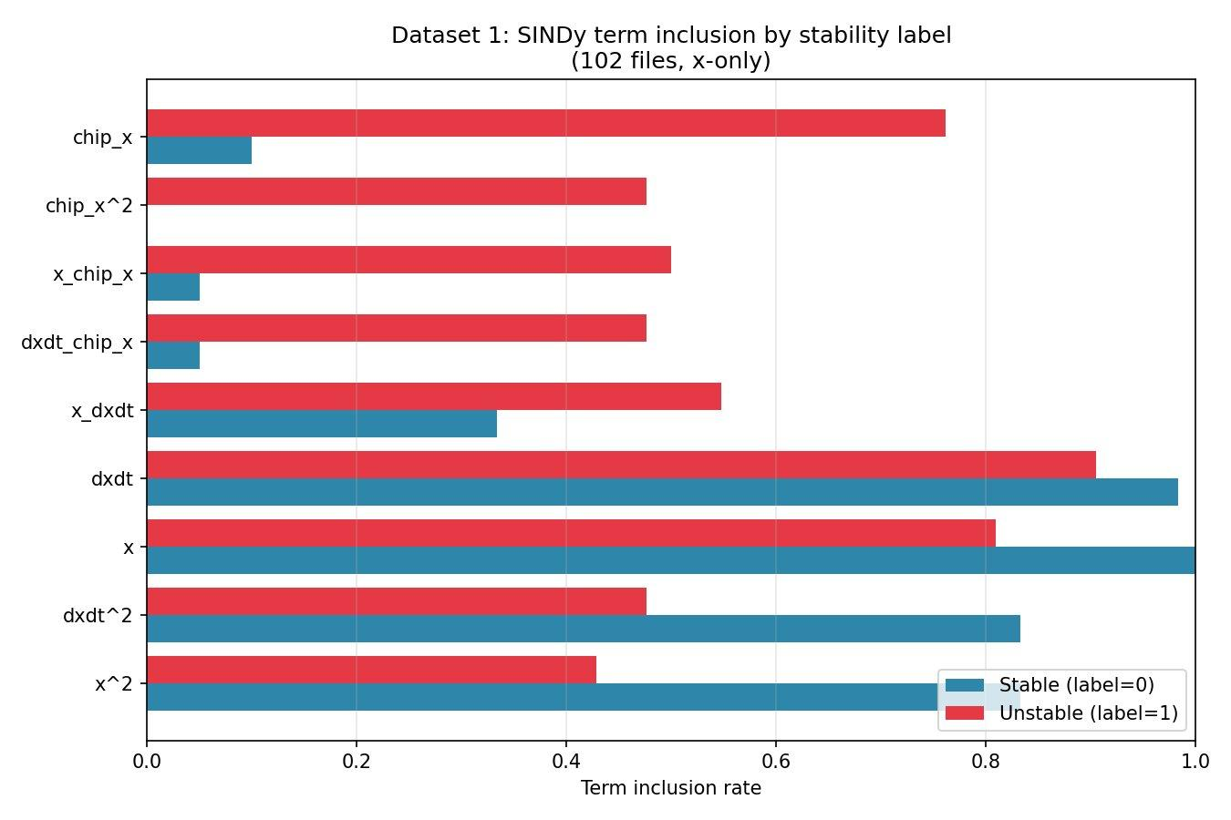
Dataset 1 SINDy-DDE term inclusion rates by stability label.

Aggregate and per-dataset replication
The full-population analysis confirmed the result is not a single-configuration artifact. Across all 32,168 files, chip_x held at roughly 29% inclusion for stable cuts and 54% for unstable. The per-dataset scatter plot shows a consistent gap between stable and unstable chip_x rates from dataset 1 through dataset 120, spanning all noise tiers.
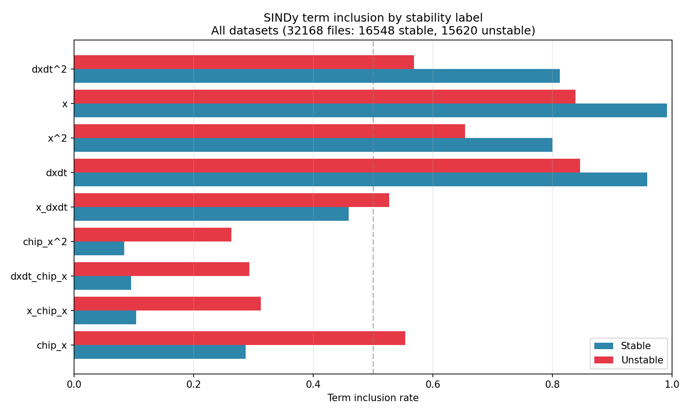
Aggregate term inclusion across all 120 datasets.
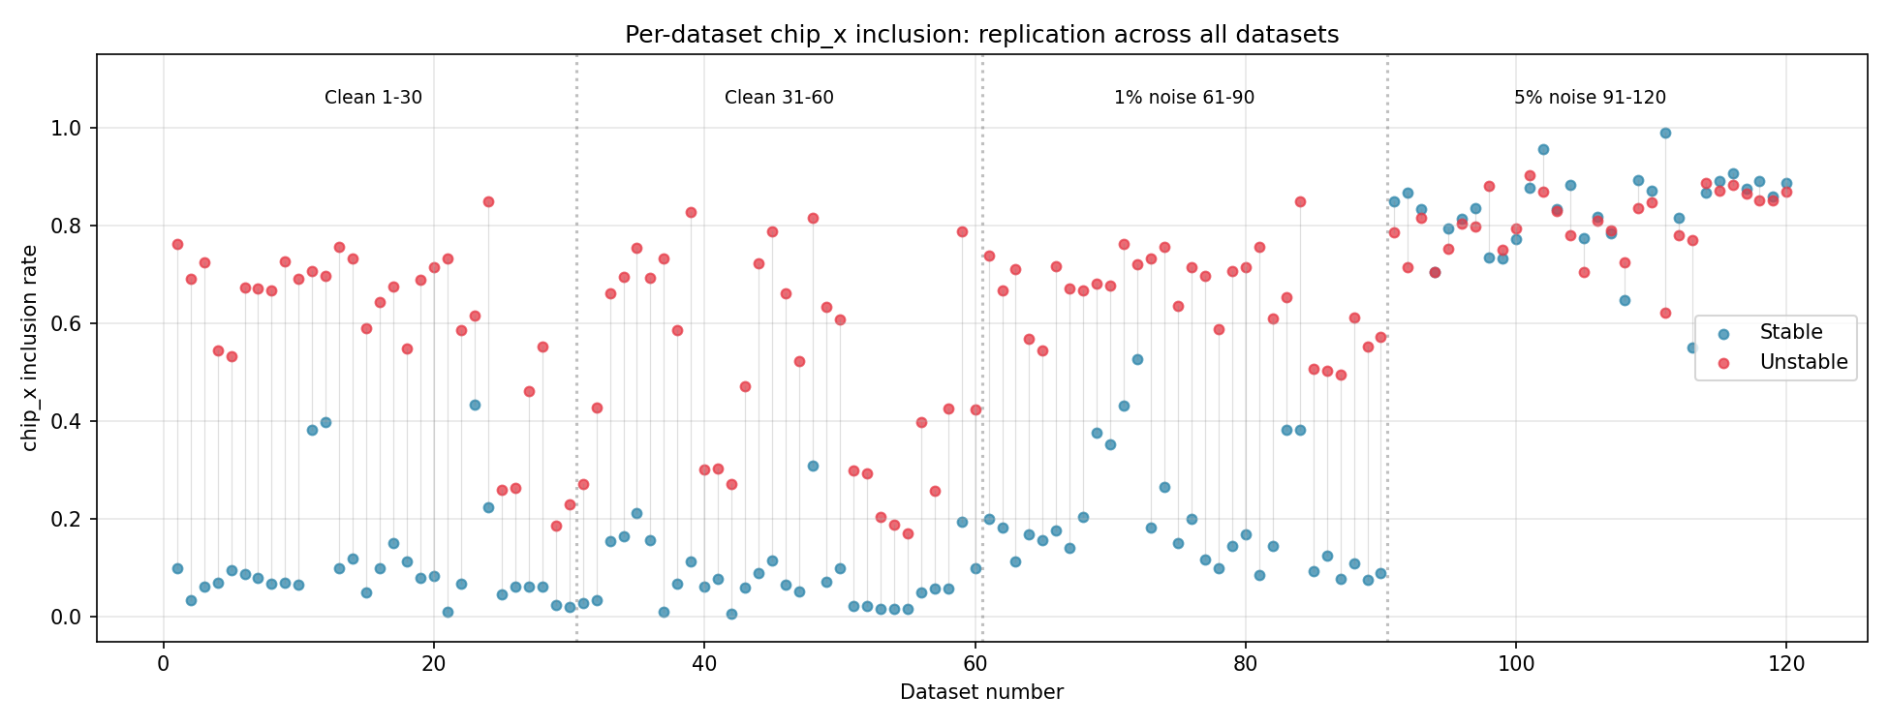
Per-dataset chip_x inclusion: stable vs unstable across all 120 datasets.

Stability boundary gradient
Binning files by b/blim showed that chip_x inclusion is not binary. It rises monotonically as cut depth approaches the stability limit, reaching roughly 22% at b/blim below 0.5 and 58% above 1.5. The nonlinear chip terms show the same trend but at lower inclusion rates, with a visible jump at the b/blim = 1.0 boundary. SINDy is detecting the growing influence of regenerative coupling continuously, not just flagging a threshold crossing.
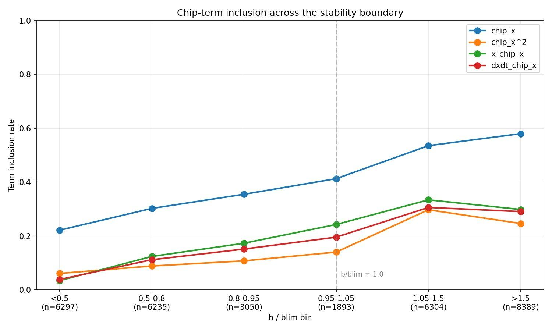
Stability boundary gradient: chip_x and related term inclusion as a function of b/blim.

Noise sensitivity
At 5% noise, chip_x inclusion in stable cuts rises from 10% to 84%, while unstable inclusion rises from 45% to 80%. The discrimination gap that makes chip_x a reliable chatter indicator nearly disappears. This directly motivates the KAN-PINN for Phase 5: a physics-informed neural network that fits the full dynamics can potentially maintain selectivity under noise where sparse regression cannot, because it does not rely on term sparsity to encode the physics.
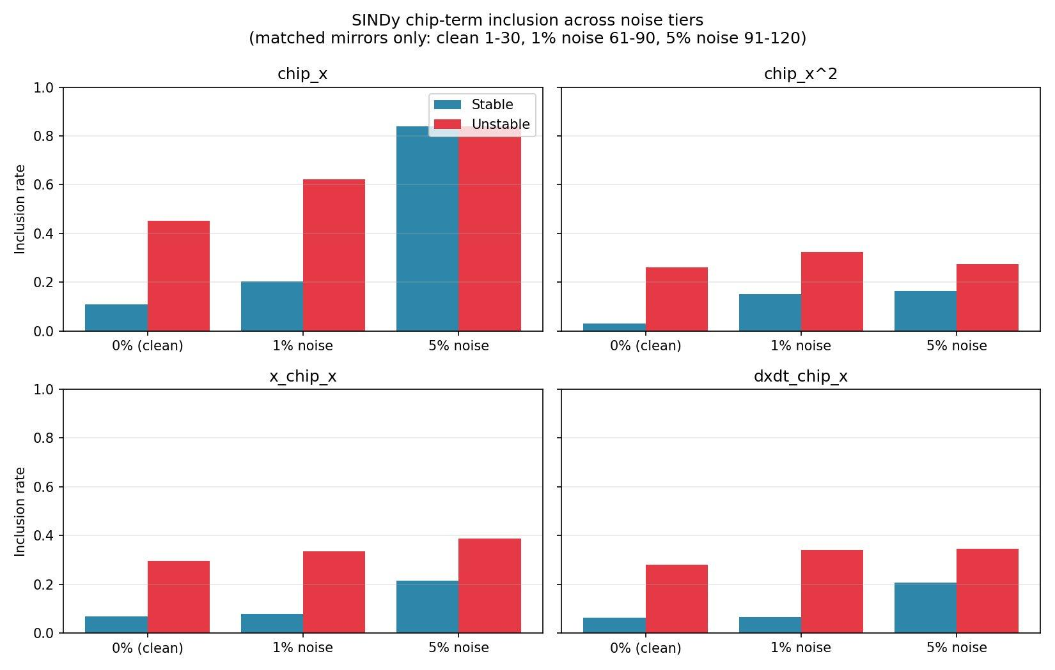
Noise sensitivity: chip_x inclusion under 0%, 1%, and 5% noise.

4. Conclusions and Next Steps
Four findings close out Phase 4. First, chip_x is the primary physics-level chatter discriminator, with a 3 to 7x higher inclusion rate in unstable cuts, replicated across all 120 datasets. Second, chip-term activation rises continuously with b/blim, meaning SINDy captures the gradual growth of regenerative coupling rather than a binary state change. Third, the pattern is robust across all configurations in the clean data. Fourth, noise at 5% collapses discrimination, establishing a clear performance ceiling for sparse regression.
These results confirm that the data contains the expected regenerative chatter physics and set the analytical baseline for Phase 5. The KAN-PINN will attempt to recover the same physics without a predefined term library, and PySR symbolic regression on its learned edges will be compared directly against the SINDy recovery here.

Time Description
Task | Description | Hours
Literature Review | Reviewed SINDy-DDE formulations, regenerative chatter theory, Chaos Theory and its implications to our project with the help of the paper “Data Driven Model Discovery using KAN” | 6
SINDy Code Compilation 1 | Built the single-dataset SINDy-DDE pipeline for Dataset 1: delay embedding, candidate library construction, and sparse regression with STLSQ on 102 files. | 3
SINDy Code Compilation 2 | Extended the pipeline to all 120 datasets (32,168 files) with batch processing on the HPC cluster, adding noise-tier comparison and per-dataset replication analysis. | 3
Feature Preprocessing and Delay Embedding | Implemented the chip thickness computation x(t) - x(t-tau) using tooth-pass period tau from dataset metadata, validated against known stable and unstable files from Dataset 1. | 3
Results Analysis | Analyzed term inclusion rates across stability labels, produced b/blim gradient binning, and compared noise tiers across matched datasets. | 3
Research Update Writing | Drafted Phase 4 research update covering methodology, results, and conclusions along with updated Project Plan | 2
Total |  | 20

Research Update 2

1. State Before This Work
The last update finished the SINDy-DDE analysis. It found that one term, the regenerative chip term chip_x, is the clearest physics signal for chatter. It shows up 3 to 7 times more often in unstable cuts, and this holds across all 120 datasets. It also found that adding 5 percent noise wipes out that signal. That set a clear limit for the simple regression method and was the reason to move to a physics-informed neural model.
This update is about the next stage. The job here was to set up the full Phase 1 to Phase 3 plan: get everything running on the Great Lakes cluster, build a separate physics check based on Altintas-Budak stability theory, and build the signal analysis pipeline that turns raw machining data into a stability score the neural model can later learn from. None of this existed before. The earlier work was loose scripts run by hand. This stage turns it into a clean code base with cluster jobs that anyone can rerun.
The final goal is a T-KAN-PINN model with an explainability layer. It will use DiCE-style counterfactuals that only change the knobs an operator can actually turn, like spindle speed and depth of cut, and suggest small, physically sensible changes that move a cut from unstable back to stable.

2. What Was Built

2.1 Code base and Great Lakes setup
A clean package was set up under src/pri2m. It holds the shared config, the data loaders, the Altintas-Budak check, the signal and divergence tools, the Phase 3 stage gates, the model checkpoint cleanup, and the reporting helpers. SLURM wrappers were added so each step runs on the cluster in a fixed order. The big preprocessed data files stay on Great Lakes. Only code, configs, summary tables, logs, and final figures are kept on the local machine. A handoff file tracks the status, blockers, fixes, and next goals so the work can be picked up without guessing.
The SINDy summary was re-checked on Great Lakes and matched: 32,168 preprocessed rows, 120 datasets, and 0 fit failures. The six development datasets were confirmed (clean 1, 4, 29, 35, 39, and the 5 percent noisy copy 91).

2.2 Altintas-Budak stability verifier
A standard milling stability lobe model was built as a separate physics check. It works out the machine’s vibration response on each axis, applies the cutting factors, and solves for the deepest cut that stays stable and the spindle speeds that go with it. This lets us test whether the data really behaves like the textbook chatter theory, instead of just trusting the stable/unstable labels in the dataset.
The check runs in three modes. The textbook test passed, which shows the math and pipeline work. The dev metadata test passed, which shows the six dev datasets have the properties we expect. The third test, comparing predicted depth limits against the data, ran but is only a warning for now. The exact textbook constants and the way the data generator sets up the cut are not known yet, so these depth numbers are a placeholder, not a final pass. This is the main open physics question for Phase 3.

2.3 Phase 2 signal extraction and PSD pipeline
A signal extractor was built to read the raw H5 files on Great Lakes and save small bundles for four signals: tool position x, tool position y, force x, and force y. A small pilot ran first on the dev and anomaly datasets plus noisy dataset 91, with zero failures. The full clean run then covered all 60 clean datasets.
The PSD pipeline turns each signal into a power spectrum, which simply shows how much energy sits at each frequency. It then tags each file with a spectral sanity category, such as clean tooth-pass behavior, a chatter-like peak near the machine’s natural frequency, a mixed case, or an indeterminate case. The full clean run processed 18,221 files and 72,884 signal rows with zero failures. The tags flagged strong odd behavior in datasets 44 to 48, which lines up with the long-standing note that these cuts may be over-called as unstable.

3. The Divergence Metric Problem and the Fix
The first plan was to measure how different the stable and unstable spectra are inside each b/blim bin, using a standard distance score (Jensen-Shannon divergence). When this ran, it gave zero usable rows. The reason is simple once you see it. The number b/blim is the stability line itself. Cuts below 1.0 are stable and cuts above 1.0 are unstable, almost by definition. So a single bin almost never has both stable and unstable files in it, which means there is nothing to compare inside a bin. This stayed true even on the full dataset, so it is a built-in property of the data, not a small-sample fluke.
The fix was to change the question. Instead of comparing the two labels inside one bin, each bin is now compared against a fixed stable reference spectrum, built from the same signal, tooth count, and cut direction. This measures how far the spectrum has drifted away from a stable cut as the cut gets deeper. This shape is also a better fit for the neural model later, because it gives a smooth penalty that grows as the cut gets more unstable, instead of an on/off jump.
Two methodology guards were added so this metric is trustworthy:
1. The stable reference is now chosen by physics only. It uses the lowest b/blim samples in each facet and never uses the stability label to pick the reference. This avoids label leakage into something that is meant to be a spectral loss.
2. A hard stability floor was added. Reference samples must have b/blim at or below 0.80. If a facet does not have enough samples under that floor, the row is marked as insufficient rather than quietly using the least unstable samples. This protects the thin facets that show up at full scale.
One honest caveat is recorded in the notes. The lowest b/blim bin overlaps the reference set by design, so its divergence is an anchor near zero and not an independent test point. The curve should be read by its shape above the reference band, especially the rise across b/blim equal to 1.0. Both guards and this caveat are now applied and recorded in the production run metadata.

4. Results
The full clean run shows the expected physics clearly, and more cleanly than the earlier pilot. For the biggest group of cuts (force x, four teeth, climb cut, about fifteen thousand files), the score stays very low and flat while the cut is stable, then climbs steadily and keeps speeding up once the cut crosses the stability line.
b/blim bin | JS divergence (force x, 4 teeth, climb) | label
0.00 to 0.50 | 0.00034 | stable
0.50 to 0.75 | 0.00825 | stable
0.75 to 1.00 | 0.01342 | stable
1.00 to 1.25 | 0.02124 | unstable
1.25 to 1.50 | 0.04190 | unstable
1.50 to 2.00 | 0.08225 | unstable
2.00 to 3.00 | 0.14274 | unstable
3.00 to 5.00 | 0.27375 | unstable
5.00 and above | 0.41837 | unstable
What this means in plain terms: while the cut is stable, its spectrum looks almost identical to a known stable cut, so the score is near zero. The moment the cut passes the stability line at b/blim equal to 1.0, the spectrum starts changing fast, and it keeps changing more as the cut goes deeper. By the deepest bin the score is about 31 times higher than the last stable bin, and more than an order of magnitude above the near-boundary stable region. The score does not just flip on and off at the boundary, it rises smoothly with how unstable the cut is. So it behaves less like a stable/unstable classifier and more like a severity measure for instability. That is exactly the behavior we want, because it gives the neural model a graded signal to learn from instead of a hard yes/no.
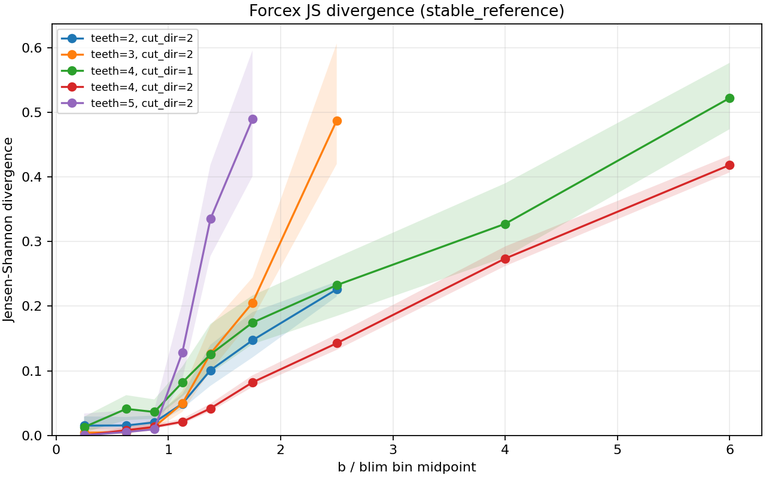
Full 60 clean datasets, force x. The score stays low and flat while the cut is stable, then bends upward right at the stability line (b/blim equal to 1.0) and keeps climbing. The bend at 1.0 is the key feature: it shows the spectrum reacts to real instability, not to the label. The colored curves are different physical regimes (tooth count and cut direction). The four-tooth climb-cut curve is the smooth, well-populated one and should be read as the main result. The five-tooth and three-tooth curves rise more sharply but have thinner data support, so they are supportive rather than central. This makes the force channel the main candidate for the Phase 3 spectral loss.
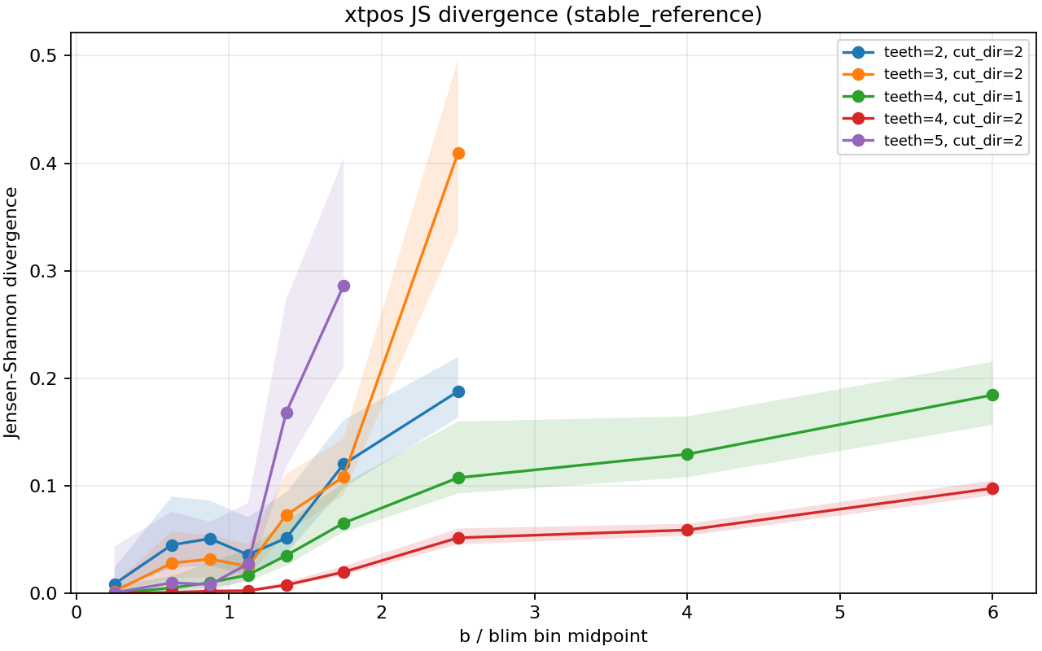
Full 60 clean datasets, tool position x. Same boundary-aligned shape as the force signal, but at a lower magnitude in the dominant four-tooth climb-cut regime. Tool position still carries stability information, just less strongly than force, so force channels look more sensitive for spectral loss design.
The full clean run produced 156 facet and bin rows across 60 datasets. Of these, 152 are in good standing and 4 are flagged as insufficient. All four flagged rows are the same thin cell (five teeth, climb cut, the 2 to 3 b/blim bin) that held only a single file, so the pipeline correctly marked it rather than producing a fake number. The stability floor stranded no facet. There were zero aggregation failures.
The noisy copy, dataset 91, was also run as a small early check. Its curve keeps the same broad direction but is flatter early, bumpier, and less certain. This agrees with the earlier SINDy finding that 5 percent noise weakens chatter signatures. It is shown only as motivation for the full noisy run, not as a robustness conclusion. The full noisy datasets 61 to 120 are needed before any production robustness claim.
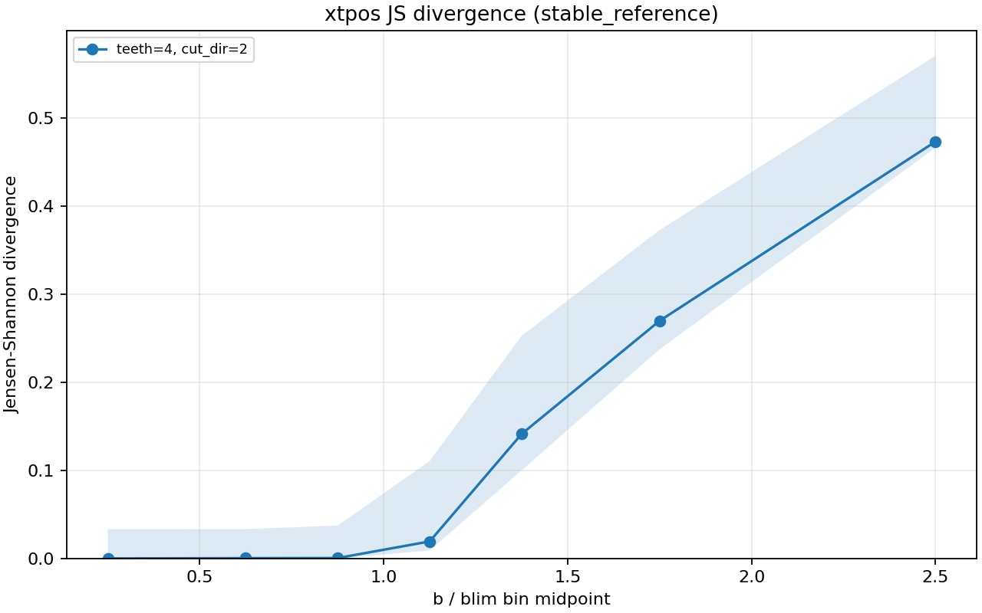
Noisy dataset 91, tool position x. The rise is weaker and the line is bumpier and less certain than the clean case. This is the expected effect of noise weakening chatter signatures and motivates the full noisy run, rather than settling the noise question.

5. Where This Stands Against the Schedule
The clean side of Phase 2 is now done, not a pilot. PSD ran on all 60 clean datasets, the per-dataset stable versus unstable PSD profile plots were produced for all 60 (120 plots across the two reported signals, zero failures), the divergence aggregation ran on the full clean set, and the rise across b/blim equal to 1.0 is confirmed on production data against the revised criterion. So Phase 2.1 through 2.4 are met on clean data.
The metric change is documented and the success criterion was revised in writing before the curves were read, so the result above is judged against the corrected target and not the old one.
What is still open is the noisy side at full scale and the physics calibration. These are covered next.

6. Obstacles and Challenges
This stage hit several real obstacles. They are listed here plainly so the path is clear.
1. Great Lakes path not mounted locally. The shared project path was not visible from the local machine, so the local environment can only hold code, configs, summaries, and final figures. The heavy data stays on the cluster. This shaped the whole local versus cluster split.
2. Transfer and path naming. The feature CSV folder name carried a space, which broke an early copy and split files into the wrong place. The folder convention was changed to a no-space name and every script and SLURM file was updated to match.
3. The within-bin divergence dead end. The first divergence design produced zero usable rows. This was not a code bug. The b/blim ratio is the stability boundary itself, so a bin is almost always all stable or all unstable. The metric had to be redesigned, not patched.
4. Label leakage risk in the fix. The first version of the new metric could have used the stability label to pick the stable reference. That would leak labels into something meant to be a spectral loss. The reference selection was moved to a physics only rule.
5. Thin facet protection. Without a floor, a facet with no truly stable samples would have used the least unstable samples as the reference and produced confident looking nonsense. A hard b/blim floor of 0.80 and an explicit insufficient flag were added.
6. Altintas-Budak calibration still open. The exact textbook constants and the data generator engagement convention are not available yet, so strict blim validation cannot pass. This is the main physics anchor risk for Phase 3 and only the data owner can unblock it.
7. Schedule pressure. The full 60 clean run was behind the planned date for a short period. It is now complete, but the noisy run at scale is still outstanding.

7. Risks and Next Steps
One verification item is now resolved. The b_over_blim provenance is verified: the CSV satisfies b_over_blim = b_mm / blim, labels match int(b_over_blim >= 1), and in-range raw H5 boundary checks have zero mismatches. A small set of low-speed rows falls below the raw boundary grid and is reported separately. This is no longer a risk apart from that small low-speed edge case.
The main open risks before the T-KAN-PINN work are:
1. The Altintas-Budak blim calibration is still open and is the physics anchor for the Phase 3 residual term. This needs the exact reference constants and the generator engagement convention from the data source. It is the one item that only the data owner can unblock.
2. The clean side is done, but the noisy datasets 61 to 120 have only been run for the single pilot dataset 91. The noise robustness story is not yet production grade.
Next steps in order:
1. Run the full noisy extraction and divergence aggregation for datasets 61 to 120 so the noise robustness story matches the clean one.
2. Start the Phase 3 baseline: the MLP with hardcoded tau and an MSE loss.
3. Get the Altintas-Budak constants and the generator engagement convention from the data owner, so the Phase 3 physics residual is not blocked.
4. Later, integrate the JS spectral loss once the Phase 3 baseline works.
The Phase 3 model work can still start on schedule, because the planned unlock order puts the spectral loss at a later stage. So the remaining Phase 2 work and the early model work can move in parallel.

8. Time Spent
This update covers the week from May 11 to May 18, about 20 hours of work.
Work | Hours
Code base setup: src/pri2m package, configs, and SLURM wrappers | 3.0
Great Lakes bring-up: install and verify the SINDy summary and dev datasets | 2.0
Altintas-Budak verifier: stability lobe model, three modes, Phase 1 check | 3.0
Signal extraction: H5 to NPZ extractor, pilot, full 60 clean run | 2.5
PSD pipeline: Welch spectra, sanity tags, 120 profile plots | 2.5
Divergence metric fix: diagnose the dead end, rebuild, add the two guards | 3.0
Full clean production run and reading the result | 1.5
Verification scripts: provenance check and reference-rule check | 1.0
Documentation: notes, handoff file, this update | 1.5
Total hours | 20.0
The largest blocks were the verifier, the metric fix, and the code base setup. These were the parts that needed real design work and debugging rather than just running jobs.

Research Update 3

1. State Before This Work
The last update closed the clean side of Phase 2. The spectra ran on all 60 clean datasets and the divergence score rose smoothly across the stability line. Three things were still open. The noisy side at full scale was not done. The Phase 2.5 noise layer was only a written plan. And there was no easy way for outside tools like RapidMiner to call the pipeline without using the full Python stack.
This update covers May 18 to May 24, about 19 hours of work. The job was to turn the Phase 2.5 plan into real code with passing tests, check the method on real data before writing new code, set up the cluster jobs that will calibrate it, and add a small RapidMiner test so the XGBoost side can be reached from outside Python.

2. Phase 2.5: Noise Characterization and Mode-Aware Filtering
Feedback on Research Update 2 raised a real gap in the current pipeline. The clean PSD and divergence results are strong, but there is still no formal way to measure how noisy a signal is, decide when enough noise has been filtered, or stop chatter from being confused with noise. A new stage, Phase 2.5, is added before the divergence-based spectral loss is wired into the neural model. Phase 2.5 is a support layer for the spectral loss and the explainability step, not a separate research thread.
Each signal is read as a mixture of three things. The first is the forced cutting response, which is the tooth-pass frequency and its harmonics. The second is the chatter response, which is the energy near the machine's natural frequency and the regenerative sidebands around it. The third is measurement or process noise, which is broadband or incoherent energy that does not line up with the physics bands or with the other channels. Filtering should only target the third one. It should not remove tooth-pass behavior or chatter signatures.
The noisy datasets in the metadata follow a two-step noise ladder against the clean datasets. The first 30 noisy datasets use 1 percent noise and each one mirrors a clean dataset. The next 30 use 5 percent noise and also mirror the same clean datasets. Each clean dataset has been matched against its 1 percent and 5 percent copies, and they share every physical parameter such as spindle speed, depth of cut, stability limit, natural frequency, tooth count, cut direction, and tool diameter. Only the noise level differs. The clean, 1 percent, and 5 percent triple is the calibration anchor for every Phase 2.5 metric.
The first checkpoint compares Dataset 1, Dataset 61, and Dataset 91. A noise metric is only kept if its scores move upward steadily across the three noise levels, either by a clear margin against the spread of the clean baseline, or by a strong statistical test when file pairing is incomplete. Metrics that fail this gate are dropped before anything else is built on them.
The Phase 2.5 metric list is grouped into families so similar estimators cannot double-vote. The PSD family includes noise floor ratio, off-harmonic energy ratio, spectral flatness, and spectral entropy. The wavelet and temporal family includes a wavelet-based noise sigma and an autocorrelation decay rate. The cross-channel family uses coherence across the four signals. The chatter-specific family separates structured chatter from broadband noise using kurtosis in the natural-frequency band, sideband energy around the natural frequency, and a tooth-pass cycle metric. A file is labeled high-noise only when at least one metric from each of the PSD, wavelet, and cross-channel families agrees.
Each file then receives a mode label: TPF-dominated clean, near-boundary transition, chatter-dominated, broadband-noise-dominated, mixed TPF and chatter, or low-speed edge. The first version uses rule-based thresholds on chatter-band energy, tooth-pass harmonic energy, noise floor ratio, and the stability ratio, calibrated against the clean datasets. A trained classifier replaces the rules if they disagree visibly with the divergence-curve evidence.
Filtering is conservative. A filtered signal is only accepted if its noise score moves into the clean baseline range for the same mode, the tooth-pass peak location and harmonic energy are preserved, chatter-band and sideband energy are not erased, the stable-reference divergence trend still rises across the stability boundary, and the noisy mirror moves measurably closer to its clean twin in spectrum and divergence space. If any check fails, the file is tagged noise-limited rather than force-filtered.
Phase 2.5 hands two things to the next stage: a mode label per file as a conditioning input, and a noise confidence score per file as a sample weight for the spectral loss. Noise-limited files are down-weighted, not dropped, so the model still sees the regime. The spectral loss is only unlocked after Phase 2.5 produces a validated noise score and a filtering acceptance rule. The baseline neural model with a simple loss does not need Phase 2.5 and can start in parallel.
The same outputs support the explainability step. The counterfactual recommendations will report the noise score and the model confidence alongside any suggestion. For clean cuts the system can suggest efficiency moves. For near-boundary and chatter-dominated cuts it can suggest spindle and depth changes toward stable behavior. For broadband-noise cuts it refuses at the per-file level and emits a dataset-level "sensor needs attention" rollup, so the operator sees an aggregate signal instead of a long string of refusals.
Several items are deliberately out of scope for Phase 2.5 and tracked separately: within-cut non-stationarity, label confidence from physics-parameter perturbations, feasibility constraints on the counterfactual side, causal-versus-spurious feature audits, tool wear and across-cut drift, and model-output uncertainty calibration. These are listed in the spec so they are not rediscovered later.

3. Phase 2.5 Check on Real Data
Before writing any new code, the Phase 2.5 ladder test was run on the spectral features that already sit in the metadata. The goal was to make sure the method itself works on real data, not just on a toy example.
Two things came out. First, all 102 files in Dataset 1 pair cleanly with the 102 files in Dataset 61 and the 102 files in Dataset 91. So the clean, 1 percent, and 5 percent triple is fully paired. Second, five metrics that already exist pass the ladder with strict monotone behavior and very small p-values. The strongest are Forcex spectral entropy, xtpos spectral entropy, and Forcex harmonic energy ratio. So the method is sound. The new metric library is being added because the chatter and cross-channel families are not in the data yet, not because the test is unproven.
A useful negative check also showed up. The sideband and kurtosis features that already exist correctly fail the ladder. That is what they should do. Chatter features should not separate clean from noisy. If they had passed, it would have meant the chatter family was being polluted by noise, which is the very confusion Phase 2.5 is meant to prevent.

4. Phase 2.5 Library and Mode Labels
The Phase 2.5 library was added in two parts. One part computes noise metrics per file. The other part gives each file a mode label.
The metric library gives 44 columns per file in four families. The PSD family covers noise floor ratio, off-harmonic energy, spectral flatness, and spectral entropy. The wavelet and temporal family covers a wavelet sigma and an autocorrelation decay rate. The cross-channel family covers coherence across the four signals. The chatter family covers kurtosis in the natural-frequency band, sideband energy around the natural frequency, and a tooth-pass cycle metric.
One real bug was caught while testing. The first version of the chatter metrics divided by the energy in a narrow band that did not contain the natural frequency for a typical machining case. This made the ratio sit at 1.0 for almost every file and useless. The fix was to divide by total signal energy instead. The metric now sits cleanly between 0 and 1. The bug only showed up because the tests used realistic numbers for the natural frequency and the tooth-pass frequency, not a textbook example.
The mode labels are: TPF-dominated clean, near-boundary transition, chatter-dominated, broadband-noise-dominated, mixed TPF and chatter, low-speed edge, and metrics unavailable. The v1 rule fires in a set order. The low-speed edge label is checked first. Then the broadband-noise label, which needs one PSD, one wavelet, and one cross-channel metric to all agree. After that the other labels are picked by chatter-band energy, TPF energy, noise floor, and the stability ratio. Five thresholds inside the rule are marked as placeholders until the calibration job sets them from the real data.
The library has 27 unit tests. 15 for the metrics and 12 for the modes. All 27 pass.

5. Cluster Wiring
Three command-line tools were added so the new library can be run on Great Lakes.
The first computes the noise metrics per file. The second runs the paired ladder test on the clean, 1 percent, and 5 percent triple and writes the list of promoted metrics. This is the step that produces the numeric thresholds for the mode rule. The third reads the metrics output and writes a mode label per file.
Two cluster job scripts run these. The compute job uses 8 CPUs, 24 GB, and 4 hours. The calibration job uses 2 CPUs, 8 GB, and 30 minutes.
One wiring mistake was caught here. The first cluster script used a flag the tool did not accept and dropped a flag the tool needed. The scripts were rewritten to match the real tools, and the cluster README was updated.
An end-to-end test builds a small synthetic ladder, runs all three tools as subprocesses, and checks that the metrics rise across the ladder, that at least one PSD metric is promoted, and that every mode label is well-formed. It passes. This is the guard that says the library, the tools, and their flags all work together.

6. RapidMiner Smoke Test
A small RapidMiner test was added. The point is not to port the whole pipeline. The point is to show RapidMiner can call a PRI2M Python script and read its outputs.
The wrapper is a stripped-down version of the archived v3 XGBoost pipeline. It keeps the v3 feature rules and the training and evaluation. It drops SHAP, LIME, DiCE, and the plot code from the original. RapidMiner runs the wrapper and reads three CSV files.
The smoke test ran on clean datasets 1 to 5 (768 rows, 60 features). Out-of-fold AUC was 0.964 and F1 was 0.885. The same model was then run on the noisy mirrors 61 to 65 at 1 percent noise and 91 to 95 at 5 percent noise. Mean AUC stayed around 0.98 at 1 percent and 0.97 at 5 percent.
This is a smoke test, not a result claim. The point is the integration path. The numbers line up with what the SINDy work showed before: the classifier holds up at 1 percent noise and starts to drift on the F1 side at 5 percent.

7. Where This Stands Against the Schedule
Phase 2 on the clean side is still done. This week added the Phase 2.5 library, the three command-line tools, the two cluster job scripts, the end-to-end test, and the RapidMiner smoke test. Phase 3 modeling has not started yet, which is fine. The MLP baseline can start in parallel with Phase 2.5, and the JS spectral loss only unlocks after Phase 2.5 produces calibrated thresholds.

8. Time Spent
This update covers May 18 to May 24, about 19 hours of work.
Work | Hours
Phase 2.5 ladder check on real metadata | 1.5
Noise metrics library: 44 metrics, four families | 4.0
Mode label module: v1 rule, seven labels | 2.0
Unit tests: 27 tests for metrics and modes | 2.0
Command-line tools: compute, calibrate, assign modes | 2.0
Cluster job scripts for Phase 2.5 and README update | 1.0
Phase 2.5 end-to-end test | 1.5
Bug fix: chatter-band normalization | 0.5
RapidMiner smoke test: wrapper and output schema | 2.5
RapidMiner clean and noisy smoke runs and review | 1.0
Documentation: handoff entries, this update | 1.0
Total hours | 19.0

Research Update 4

1. State Before This Work
The last update finished the Phase 2.5 library, the three command-line tools, the cluster wrappers, and the RapidMiner smoke test. Three things were still open: the noise-score calibration had to be hardened and rerun on the full mirror ladder, the aggregate JS divergence run on the full noisy set (datasets 61 to 120) had not been done, and several code review findings were noted but not fixed.
This update covers May 25 to May 30, about 20 hours of work. The goal was to finish everything that must be done before Phase 3 modeling can start: calibrate the noise score on a pooled ladder, close every open review finding, add the diagnostics the next meeting needs, run PSD and JS on the full noisy dataset, compare the noisy result to the clean one, and reconcile the Dataset 39 metadata fix.

2. Pooled Calibration of the Noise Score
The pilot ladder in the last update used a single triple: Dataset 1 paired with Dataset 61 and Dataset 91. That is enough to test the method, but the production noise score should not depend on one clean dataset. The pooled calibration ran over every clean dataset in 1 to 30 that has both its 1 percent mirror and its 5 percent mirror. That gives 30 mirror ladders and 7,525 paired operating points instead of one ladder of 102 files.
The pooled run promoted 10 metrics across the PSD and wavelet families. The cross-channel and chatter families abstained, which is how the family-vote rule should behave on simulation noise. There were zero inverse indicators. The strongest promoted metrics are the wavelet sigma on the tool position channels, the PSD noise floor ratio on Forcex, and the PSD spectral entropy on Forcex and xtpos.
The mode-label distribution from this calibration is the headline number for the meeting. Clean datasets 1 to 30, inside the pool, flag as broadband noise 1.6 percent of the time. Clean 31 to 60, the held-out half of the clean set, flag 0.3 percent of the time. The 1 percent noise mirrors flag at 18.7 percent. The 5 percent noise mirrors flag at 95.5 percent. The held-out clean rate matters most, because it shows the rule generalizes off the pool, not just on it.
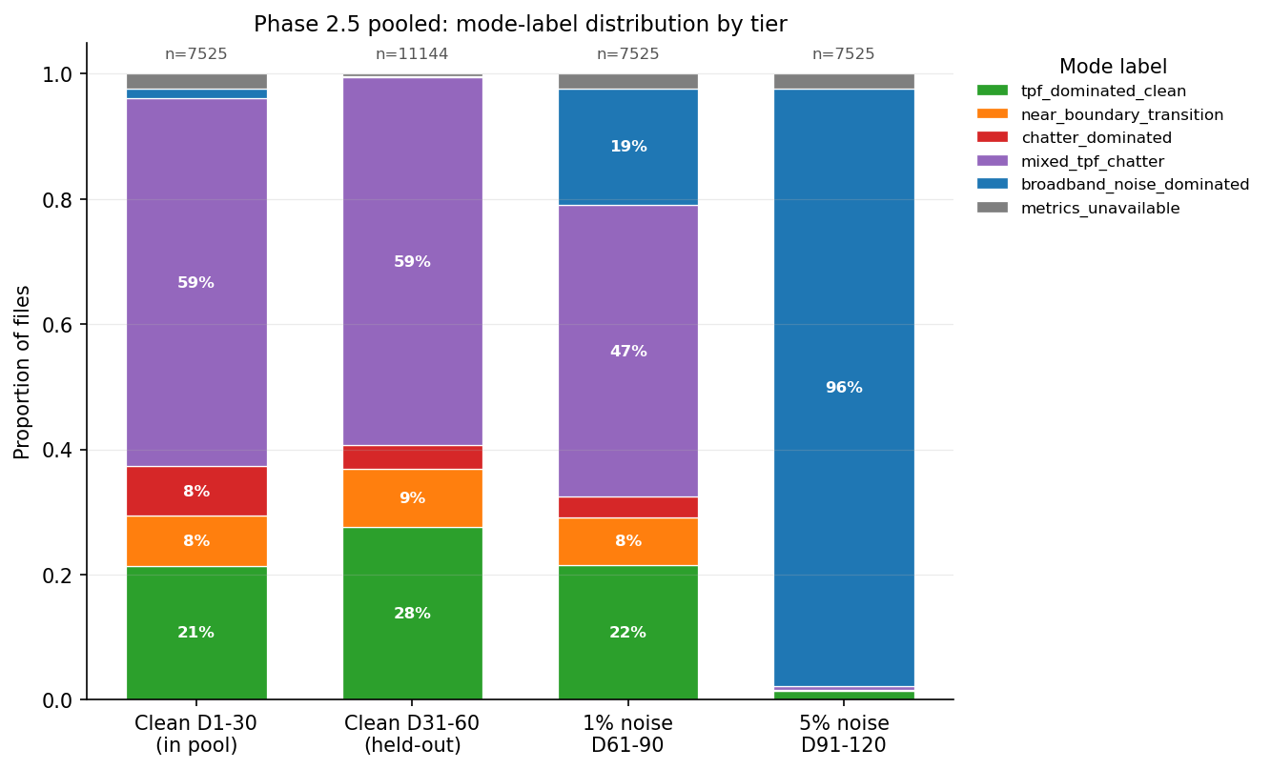
Mode-label distribution by tier, 33,719 files, 60 clean and 60 noisy datasets. The clean tiers stay mostly in TPF-dominated and mixed labels and rarely flag as broadband noise. The 5 percent noise tier is almost entirely broadband noise. The 1 percent tier sits cleanly between them. Phase 3 will use this calibration as a per-file sample weight.
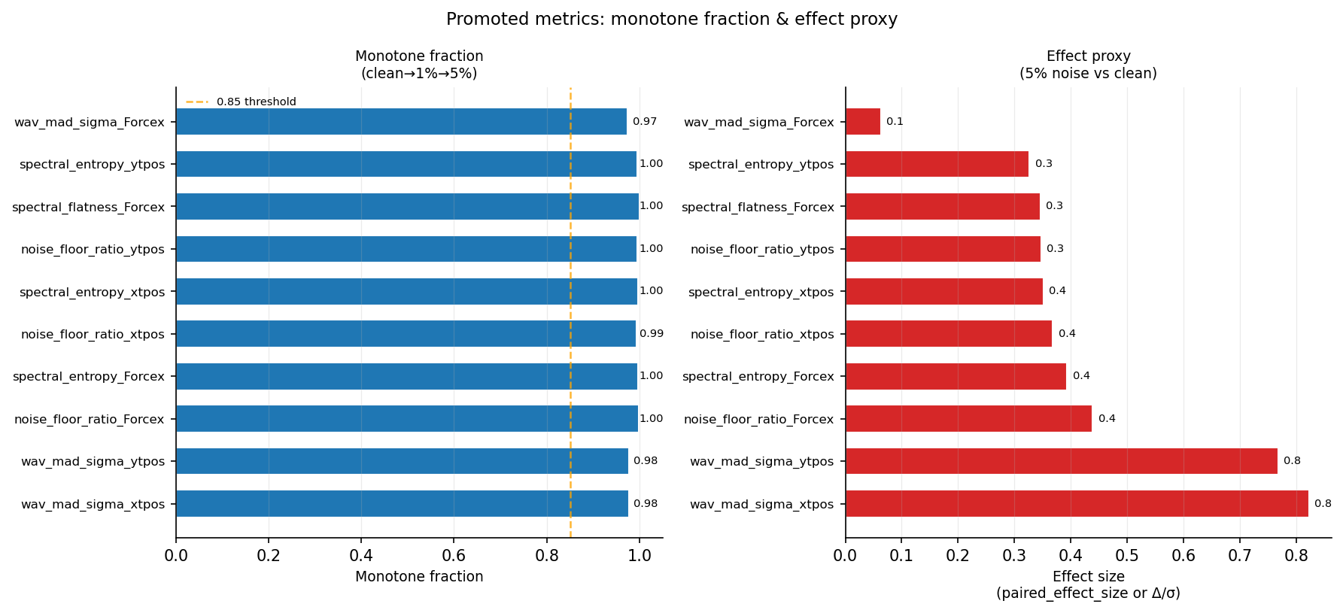
The 10 promoted noise metrics from the pooled calibration. The wavelet sigma on tool positions and the PSD noise floor and spectral entropy on Forcex are the strongest. The cross-channel and chatter families abstained, as expected on simulation noise.

3. Closing the Production Review Findings
Seven code review findings were open at the start of the week. Six are now closed with test-driven changes, and one is left open for a later session. All six landed in one batch with no conflicts. The local test suite grew from 38 tests to 68.
The findings, in short:
• The extraction script now fails closed when the canonical reader is missing, with an opt-in flag to allow the old generic H5 fallback.
• The cross-channel coherence now applies one common finite mask across the channel pair, so a NaN at different indices on the two channels no longer drives the coherence to zero.
• The noise score now averages inside each family first, then across families, so the PSD family cannot out-vote the wavelet family just because it has more metrics.
• The calibration step now refuses any metric whose paired-row coverage is below 80 percent, on top of the existing monotone and Mann-Whitney gates.
• The Pareto front script now inner-joins the baseline and each variant on dataset and file, so a filter that drops the hardest files cannot look better than it is.
• The mode assigner now rejects positive and negative infinity, not just NaN, on every promoted metric input.
The archive folder is now declared local-only, with a tracked manifest that records what each archive subdirectory holds and why it is not synced. This closes the silent-deletion risk from the last review.
One finding stays open. Four SINDy helper files live on the cluster but not in the local tree. They are needed for local reproducibility of the extractor, not for any current production run, and a single rsync will pull them when convenient. The new fail-closed extractor already checks for them.

4. Aggregate JS on the Full Noisy Set
The last update covered the full clean JS curves on 60 datasets. The full noisy run on datasets 61 to 120 ran this week. The reference rule matches the clean run: low b/blim quantile of 0.10 with a 0.80 stability floor, so the noisy curves read directly against the clean ones. Two cluster jobs ran with zero failures: 14,798 files, 59,192 signal rows, 116 of 116 reference rows usable.
The noise-robustness story holds. The score stays low and flat below the stability boundary on all four signals, and rises across b/blim equal to 1.0 just as it did on clean. On the dominant facet, Forcex with four teeth and a climb cut, the noisy result tracks the clean result closely. The table puts them side by side.
b/blim bin | Clean JS (Forcex, 4 teeth, climb) | Noisy JS (Forcex, 4 teeth, climb)
0.00 to 0.50 | 0.00034 | 0.00039
0.50 to 0.75 | 0.00825 | 0.01007
0.75 to 1.00 | 0.01342 | 0.01315
1.00 to 1.25 | 0.02124 | 0.02454
1.25 to 1.50 | 0.04190 | 0.05747
1.50 to 2.00 | 0.08225 | 0.08871
2.00 to 3.00 | 0.14274 | 0.10338
3.00 to 5.00 | 0.27375 | 0.21256
5.00 and above | 0.41837 | 0.34266
The noisy curve has almost the same shape as the clean curve in the decision region around the stability boundary, and runs a bit higher than clean in the middle bins. The Phase 3 spectral loss has to react to the rise across b/blim equal to 1.0, and that rise survives noise. The top three bins sit slightly below clean. This is a facet-composition effect, not a robustness failure. Noisy 61 to 120 mirrors only clean 1 to 30, so the highest b/blim bins draw on a single tooth-by-cut-direction facet, while the same bins on the clean side draw on four. A strict head-to-head comparison restricted to clean datasets 1 to 30 is queued and would remove this effect.
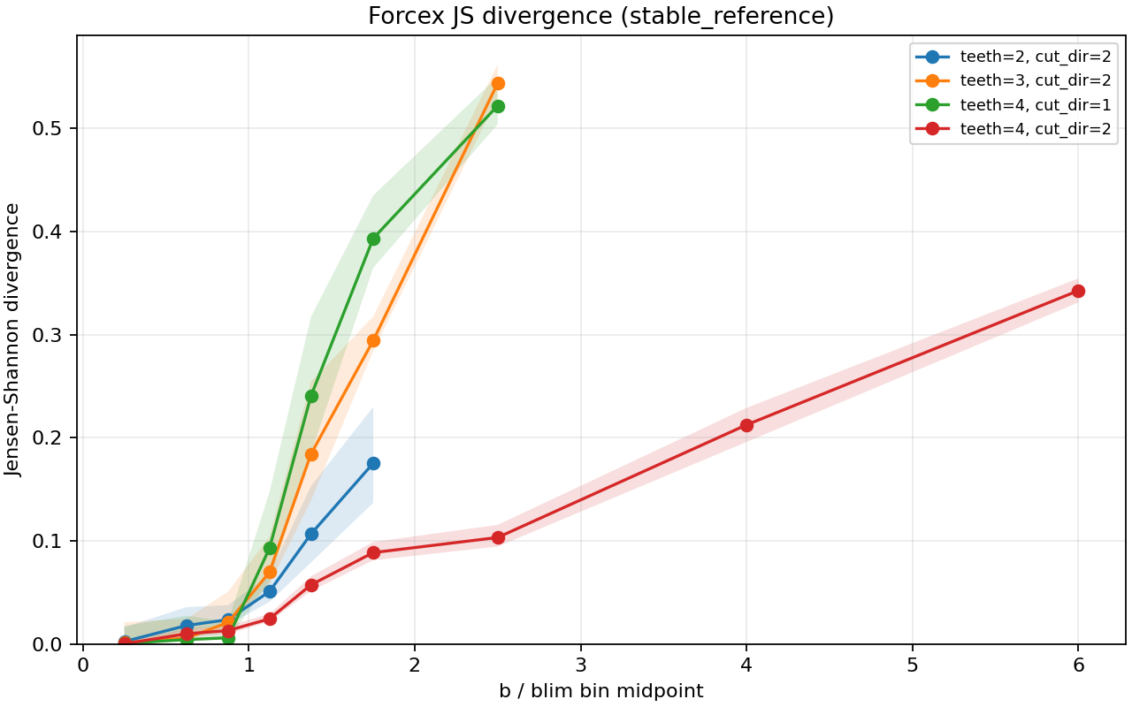
Full noisy 60 datasets, Forcex. The score stays low and flat below the boundary and rises across b/blim equal to 1.0. The shape matches the clean curve in the decision region. The slight tail dip above b/blim equal to 2 is a facet-mix artifact, documented separately.
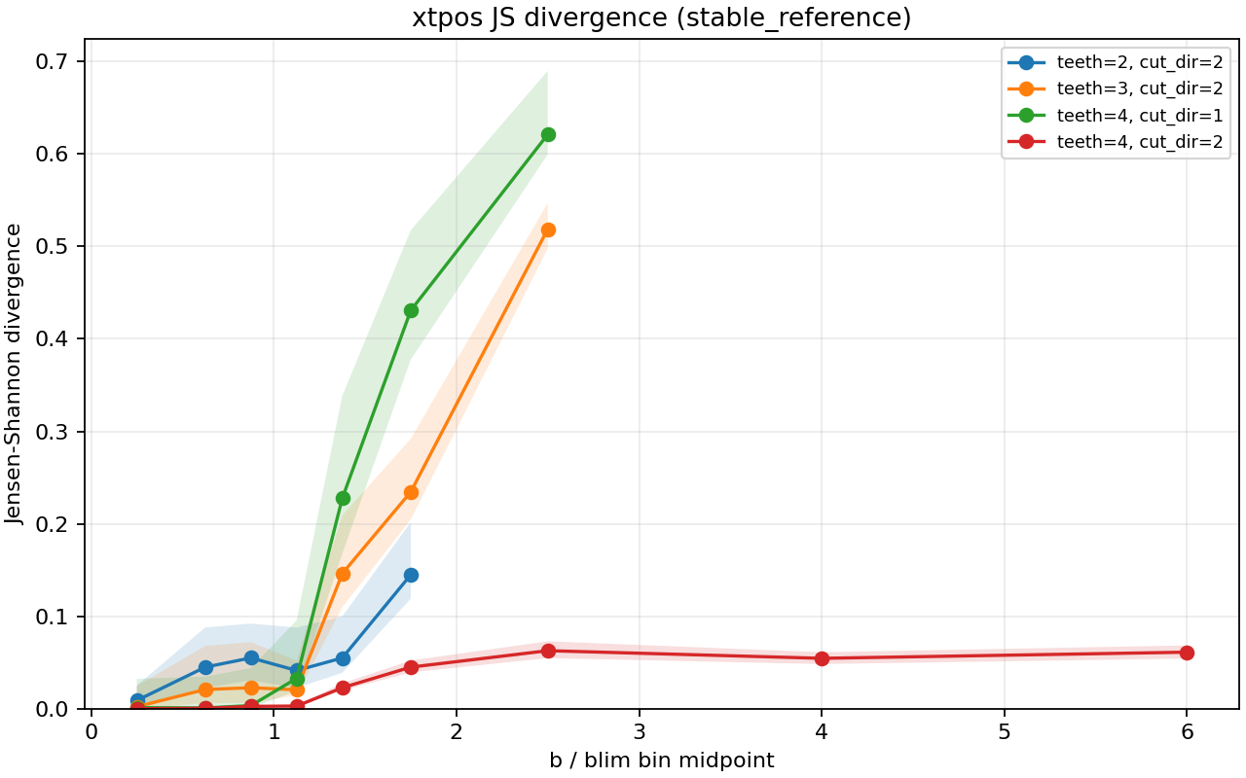
Full noisy 60 datasets, tool position x. Same boundary-aligned rise as the force signal, at a lower magnitude. Tool position carries less stability information than force under noise, which matches what the clean run showed.

5. Diagnostics for the Meeting
Two diagnostic scripts let the calibration story be discussed honestly at the meeting, not just summarized.
The first plots the per-tier mode distribution and the per-dataset broadband rate. It produces the headline 1.6, 0.3, 18.7, and 95.5 percent numbers, and it marks the few clean datasets where the broadband rate runs unusually high.
The second ranks those clean false-positive datasets. On the real local mode labels, Dataset 23 ranks first at 20.5 percent, then Dataset 12 at 10.3 percent and Dataset 13 at 6.9 percent. The script will report the per-metric driver once the full noise-metrics CSV from the cluster is fed into it. The aim is to learn, before treating any of these as a real false positive, whether those clean datasets are chatter-heavy regimes where the broadband label is correct, are missing metrics, or are threshold artifacts.

6. Where This Stands Against the Schedule
The clean side of Phase 2 was already done before this week. This week added the pooled noise calibration with 10 promoted metrics, six closed review findings, the two diagnostic scripts, and the full noisy JS run on 60 datasets. A calibrated rule, not a placeholder, now produces the mode labels on all 33,719 files in the noise-metrics CSV.
So everything Phase 2 and Phase 2.5 owe Phase 3 is in place: a per-file noise score for sample weighting, a per-file mode label for conditioning, stable-reference JS curves on the full clean and noisy data for the spectral loss head, and provenance-verified b/blim for the supervised label. The Phase 3 MLP baseline can start now, alongside the next steps in Section 8.

7. Summary
Phase 2 was the bridge between the raw machining data and the Phase 3 model. The goal was to turn each cut into a numeric measure of how unstable it is, in a form the model can learn from. Here is what Phase 2 produced and what it hands to Phase 3.
The spectral pipeline. Every raw file became a power spectrum, the spectrum was compared to a physics-only stable reference, and the result was scored with Jensen-Shannon divergence. On all 60 clean datasets and all 60 noisy datasets, the score stays low and flat while the cut is stable and rises smoothly across the stability boundary at b/blim equal to 1.0. The rise is a graded severity measure, not a stable-versus-unstable switch. This is the spectral signal the Phase 3 spectral loss head will train against.
Noise robustness. The noisy 60 run, at 1 percent and 5 percent simulated noise, kept the same boundary-aligned rise, and in the middle bins the rise is actually stronger under noise. This is the main robustness result so far. It says the spectral loss works on data that is not perfectly clean, a property the eventual hardware data will need.
Noise characterization. The Phase 2.5 library produces 44 candidate noise metrics per file. A pooled calibration on 30 mirror ladders and 7,525 paired operating points kept 10 of them, all in the PSD and wavelet families, all monotone in noise level, all with coverage above 97 percent. Each of the 33,719 files now carries one of seven mode labels and a calibrated noise score. The held-out clean false-positive rate for the broadband-noise label is 0.3 percent, and the 5 percent noise detection rate is 95.5 percent. The gate detects noise reliably without erasing chatter or TPF structure on clean data.
Label provenance. The stability label is verified end to end. The b/blim column equals b_mm divided by blim, the label is exactly int(b/blim >= 1), and the blim values match the raw stability-boundary files for every operating point inside the boundary grid. The supervised target for Phase 3 is not corrupted anywhere in the pipeline.
Code state. Six of seven review findings are closed with their own tests, the local test suite is at 68 of 68, the archive folder is local-only with a tracked manifest, and the cluster sync wrapper uses one Duo prompt per transfer. The pipeline is in a state where Phase 3 can pull on it without quiet failures.
How this helps Phase 3. Phase 3 is a supervised model first, then a physics-informed neural model. Phase 2 hands it four things: the mode label as a conditioning input, the noise score as a per-file sample weight, the 10 promoted noise metrics as auxiliary scalar features, and the stable-reference JS curve as the spectral fidelity loss head. The verified b/blim is both the supervised target and the input to the eventual physics residual.

8. Time Spent
This update covers May 25 to May 30, about 20 hours of work.
Work | Hours
Pooled mirror calibration on 30 ladders and result review | 3.0
Closing six review findings with TDD, integration, and full suite | 5.0
Mode threshold retuning against pooled clean p95 | 1.0
Phase 2.5 meeting figures script | 1.5
Clean false-positive diagnostic script | 1.5
Self-contained sbatch wrappers for noisy 61 to 120 PSD and JS | 1.5
Noisy JS result analysis and clean-versus-noisy comparison | 1.5
SSH multiplexing fix on the cluster sync wrapper | 0.5
Dataset 39 teeth verification and cross-check across 120 datasets | 1.0
Archive policy and manifest | 0.5
Forcey Dataset 19 diagnostic and v3 calibration staging | 1.5
Research update | 1.5
Total hours | 20.0
The two biggest blocks were the code-hardening batch and the noisy JS run with its clean comparison. Both are the kind of work that has to land before Phase 3 modeling starts, even though neither moves the modeling itself forward.

